Assignment 2- Case Study

Stage 3 Lab Activities

SmartCare Domain Modelling
AI OFF -> AI ON -> COMPARE -> VERIFY | 1 hour

A - Requirements Review
Highlight nouns, verbs and business rules in SmartCare v0.2.
Nouns kept as candidate concepts: patient, practitioner, appointment, status, date and time, time slot, identifier, name, contact details, appointment history, clinic.
Verbs as candidate behavior: create, search, modify, book, reject, cancel, record, display, order, store, retrieve.
Business rules:
• BR-1: no two active appointments may exist for the same practitioner at the same date and time (FR-06, NFR-01).
• BR-2: a booking is rejected unless every required value is supplied (FR-07).
• BR-3: cancelling an appointment sets its status to cancelled and never deletes the record (FR-09, US-04).
• BR-4: every appointment carries a status (FR-08).
• BR-5: an update changes the existing record instead of creating a second copy (FR-03).
• BR-6: patient, practitioner and appointment data survives the program closing (FR-12, US-05).
• BR-7: a rejection is reported to the user as a message, never as an unhandled Python error (NFR-02, NFR-05).

B - Candidate Classes
Record candidate concepts, supporting requirements, state and behaviour.
Concepts | Supporting requirements | State | Behaviour
Patient | FR-01, FR-02, FR-03, FR-11, US-01 | patient_id, name, date_of_birth, phone | update_details(), matches(), history()
Practitioner | FR-04, FR-06, FR-10, US-06 | practitioner_id, name, role | is_busy(), schedule_for()
Appointment | FR-05, FR-06, FR-07, FR-08, FR-09 | appointment_id, patient, practitioner, date_time, status | cancel(), is_active()
Clinic | FR-02, FR-06, FR-10, FR-11, FR-12 | patient, practitioner and appointment registers | register_patient(), find_patient(), book_appointment(), save(), load()
Name | FR-01, FR-04 | String | none
Status | FR-08, FR-09 | one of Booked, Cancelled, Completed | none
Cancellation | FR-09 | none of its own | V

C - CRC Cards
Create CRC cards for Patient, Practitioner and Appointment.
Patient
Responsibilities | Collaborators
Supplies its appointment history, including cancelled | Appointment
Report if it matches a search term, by name or identifier | None
Practitioner
Responsibilities | Collaborators
Report whether there is an active appointment at a given date and time | Appointment
Supplies appointments for a chosen day | Appointment
Appointment
Responsibilities | Collaborators
Refuse to create when a value is missing | None
Know the patient, practitioner, date and time it belongs to | Patient, practitioner

D - UML Model
Draw classes, attributes, operations, associations and multiplicities.
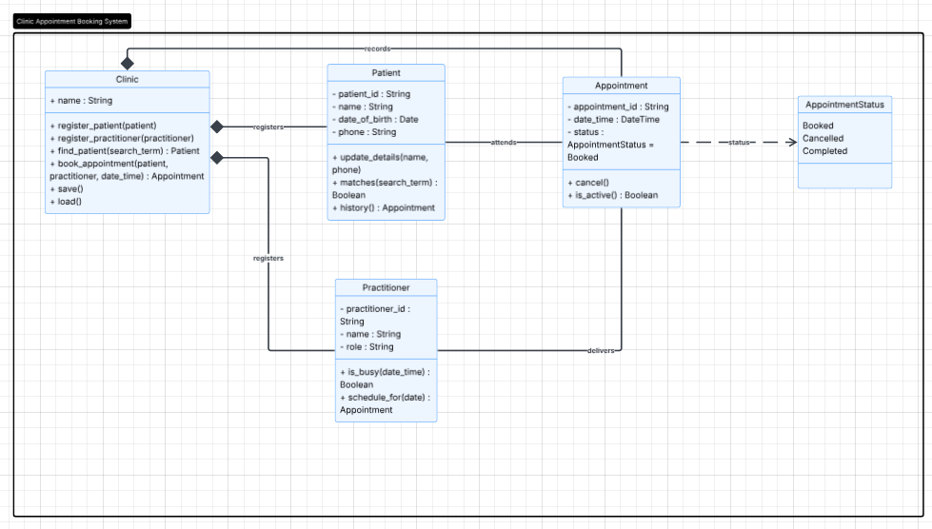
Made in lucid charts

E - AI Design Review
Ask AI to suggest classes and relationships using only confirmed requirements; require supporting requirement IDs.
Prompt: Using only the confirmed requirements, suggest the classes and relationships for a domain camodel. For every class you suggest, cite the requirement ID that supports it. Do not suggest a class that no requirement ID supports.
AI answer:
1. Patient
Supported by
- FR-01: Create a patient record.
- FR-02: Search records.
- FR-03: Modify records.
- FR-11: Display appointment history for a patient.
2. Practitioner
Supported by
- FR-04: Create a practitioner record.
- FR-10: Display appointments for a practitioner.
3. Appointment
Supported by
- FR-05: Create appointment bookings.
- FR-06: Prevent double bookings.
- FR-08: Record appointment status.
- FR-09: Cancel appointments while retaining history.
- FR-10: Display practitioner appointments.
- FR-11: Display patient appointment history.

F - Compare and Decide
Record at least one accepted, modified and rejected AI suggestion.
Accept all of these classes, as these are already included in my responses. Co-pilot essentially just restated the most basic answers.

G - Python Skeletons
Create simple Patient, Practitioner and Appointment class skeletons.

